**DAY5NAME: VISHAL.M**

**ROLL NO: 727721eucs181**

**CLASS EXERCISE 1 :**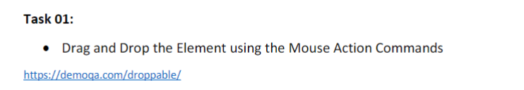

**CODE:**

package com.day5;

import org.openqa.selenium.By;

import org.openqa.selenium.WebDriver;

import org.openqa.selenium.WebElement;

import org.openqa.selenium.chrome.ChromeDriver;

import org.openqa.selenium.chrome.ChromeOptions;

import org.openqa.selenium.interactions.Actions;

import io.github.bonigarcia.wdm.WebDriverManager;

public class CE_1 {

public static void main(String[] args) {

ChromeOptions co = new ChromeOptions();

co.addArguments("--remote-allows-origins=*");

WebDriverManager.chromedriver().setup();

WebDriver driver = new ChromeDriver();

driver.get("https://demoqa.com/droppable/");

driver.manage().window().maximize();

Actions a = new Actions(driver);

WebElement source = driver.findElement(By.id("draggable"));

WebElement destination = driver.findElement(By.id("droppable"))

a.dragAndDrop(source, destination).build().perform();

}

}

**OUTPUT:**

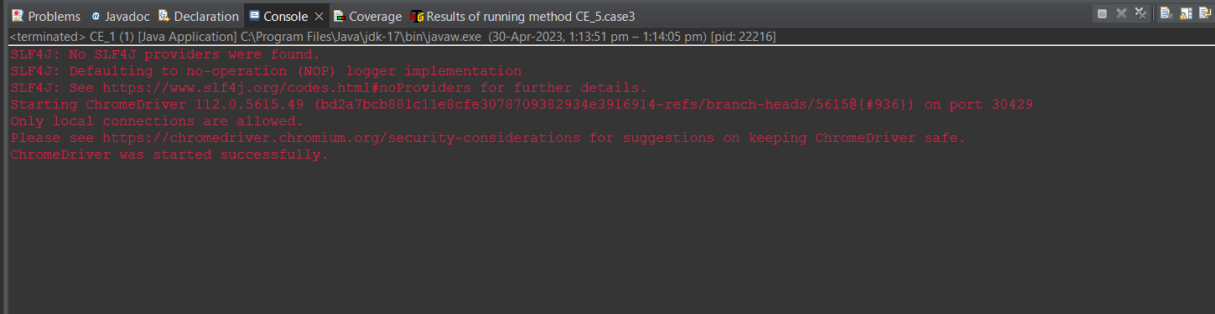

**CLASS EXERCISE 2 :**

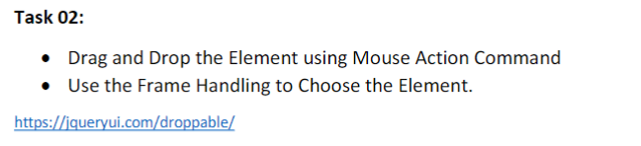

**CODE:**

package com.day5;

import org.openqa.selenium.By;

import org.openqa.selenium.WebDriver;

import org.openqa.selenium.WebElement;

import org.openqa.selenium.chrome.ChromeDriver;

import org.openqa.selenium.chrome.ChromeOptions;

import org.openqa.selenium.interactions.Actions;

import io.github.bonigarcia.wdm.WebDriverManager;

public class CE_2 {

public static void main(String[] args) {

ChromeOptions co = new ChromeOptions();

co.addArguments("--remote-allows-origins=*");

WebDriverManager.chromedriver().setup();

WebDriver driver = new ChromeDriver();

driver.get("https://jqueryui.com/droppable/");

driver.manage().window().maximize();

driver.switchTo().frame(0);

Actions a = new Actions(driver);

WebElement source = driver.findElement(By.id("draggable"));

WebElement destination = driver.findElement(By.id("droppable"))

a.dragAndDrop(source, destination).build().perform();

}

} **OUTPUT:**

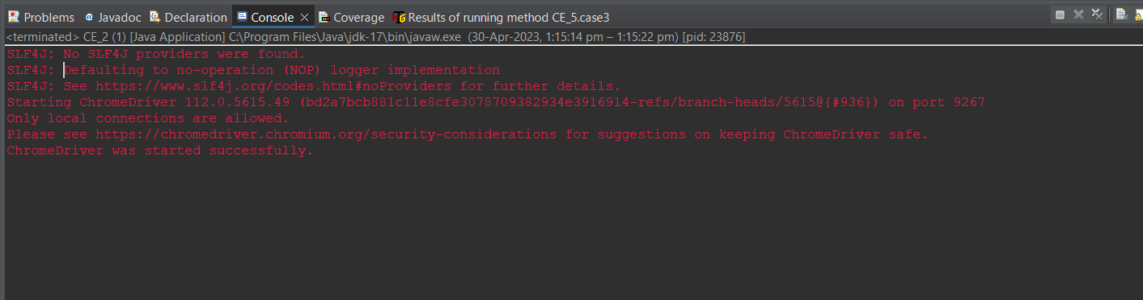

**CLASS EXERCISE 3 :**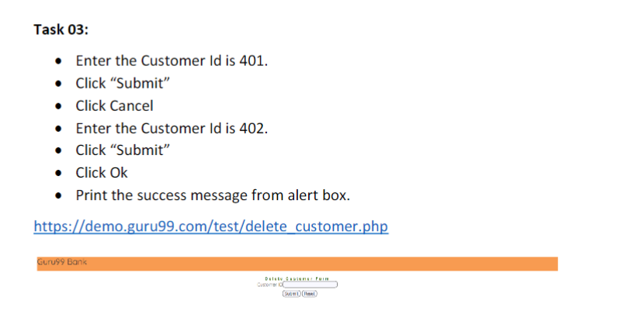

**CODE:**

package com.day5;

import org.openqa.selenium.Alert;

import org.openqa.selenium.By;

import org.openqa.selenium.WebDriver;

import org.openqa.selenium.WebElement;

import org.openqa.selenium.chrome.ChromeDriver;

import org.openqa.selenium.chrome.ChromeOptions;

import io.github.bonigarcia.wdm.WebDriverManager;

public class CE_3 {

public static void main(String[] args) throws InterruptedException {

// TODO Auto-generated method stub

ChromeOptions co = new ChromeOptions();

co.addArguments("--remote-allows-origins=*");

WebDriverManager.chromedriver().setup();

WebDriver driver = new ChromeDriver();

driver.get("https://demo.guru99.com/test/delete_customer.php");

driver.manage().window().maximize();

WebElement number = driver.findElement(By.xpath("/html/body/form/table/tbody/tr[2]/td[2]/input"));

number.sendKeys("401");

WebElement submitt = driver.findElement(By.xpath("/html/body/form/table/tbody/tr[3]/td[2]/input[1]"));

Thread.sleep(3000);

submitt.submit();

Alert alert = driver.switchTo().alert();

alert.dismiss();

number.clear();

number.sendKeys("402");

submitt.click();

Alert alert1 = driver.switchTo().alert();

alert1.accept();

Alert alert3 = driver.switchTo().alert();

String mssg = alert3.getText();

System.out.print(mssg);

driver.switchTo().alert().accept();

}

} **OUTPUT:**

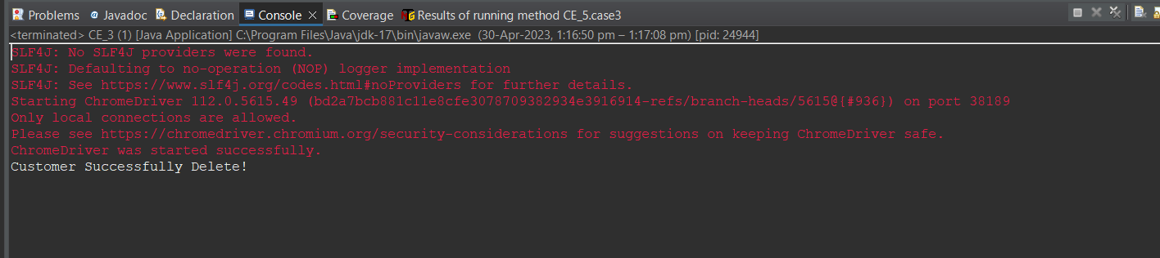

**CLASS EXERCISE 4 :**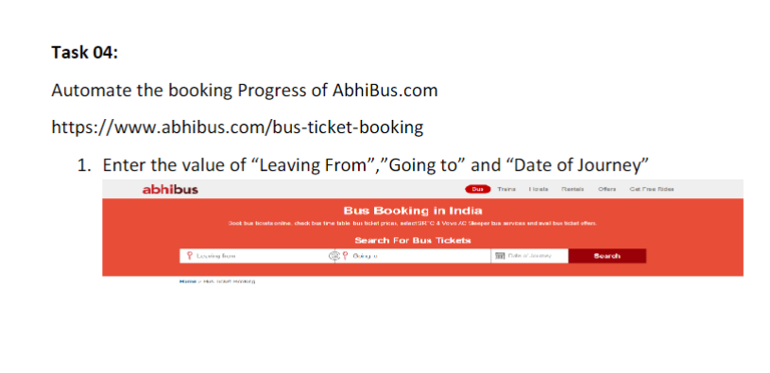

**CODE:**

package com.day5;

import org.openqa.selenium.By;

import org.openqa.selenium.JavascriptExecutor;

import org.openqa.selenium.Keys;

import org.openqa.selenium.WebDriver;

import org.openqa.selenium.WebElement;

import org.openqa.selenium.chrome.ChromeDriver;

import org.openqa.selenium.chrome.ChromeOptions;

import org.openqa.selenium.interactions.Actions;

import org.openqa.selenium.support.ui.Select;

import io.github.bonigarcia.wdm.WebDriverManager;

public class CE_4 {

public static void main(String[] args) throws InterruptedException {

ChromeOptions co = new ChromeOptions();

co.addArguments("--remote-allows-origins=*");

WebDriverManager.chromedriver().setup();

WebDriver driver = new ChromeDriver();

driver.get("https://www.abhibus.com/bus-ticket-booking");

driver.manage().window().maximize();

driver.findElement(By.name("source")).sendKeys("Trichy By Pass",Keys.ENTER);

WebElement to = driver.findElement(By.name("destination"));

to.sendKeys("Chennai");

to.sendKeys(Keys.ENTER);

WebElement datepicker = driver.findElement(By.name("journey_date"));

JavascriptExecutor js = (JavascriptExecutor) driver;

js.executeScript("arguments[0].setAttribute('value','05/05/2023')", datepicker);

WebElement search = driver.findElement(By.xpath("/html/body/section[1]/div/div[2]/form/div/div/div[1]/div[4]/button"));

search.click();

}

} **OUTPUT:**

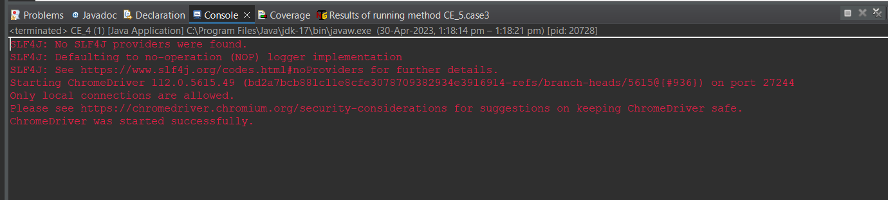

**CLASS EXERCISE 5 :**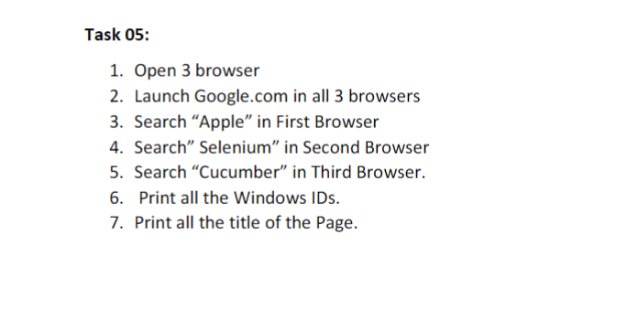

**CODE:**

package com.day5;

import org.openqa.selenium.By;

import org.openqa.selenium.Keys;

import org.openqa.selenium.WebDriver;

import org.openqa.selenium.WebElement;

import org.openqa.selenium.chrome.ChromeDriver;

import org.openqa.selenium.chrome.ChromeOptions;

import org.openqa.selenium.edge.EdgeDriver;

import io.github.bonigarcia.wdm.WebDriverManager;

public class CE_5 {

public static void main(String[] args) throws InterruptedException {

ChromeOptions co = new ChromeOptions();

co.addArguments("--remote-allows-origins=*");

WebDriverManager.chromedriver().setup();

WebDriver driver = new ChromeDriver();

driver.get("https://www.google.com");

driver.manage().window().maximize();

driver.findElement(By.id("APjFqb")).sendKeys("apple"); driver.findElement(By.xpath("/html/body/div[1]/div[3]/form/div[1]/div[1]/div[4]/center/input[1]")).click();

Thread.sleep(3000);

WebDriverManager.edgedriver().setup();

WebDriver driver1 = new EdgeDriver();

driver1.get("https://www.google.com");

driver1.manage().window().maximize();

driver1.findElement(By.id("APjFqb")).sendKeys("Selenium"); driver1.findElement(By.xpath("/html/body/div[1]/div[3]/form/div[1]/div[1]/div[4]/center/input[1]")).click();

Thread.sleep(3000);

ChromeOptions co1 = new ChromeOptions();

co1.setBinary("C:\\Program Files\\BraveSoftware\\Brave-Browser\\Application\\brave.exe");

WebDriver driver3 = new ChromeDriver(co1);

driver3.get("https://www.google.com/");

driver3.manage().window().maximize();

WebElement search3 = driver3.findElement(By.xpath("//*[@id=\"APjFqb\"]"));

search3.sendKeys("Cucumber");

search3.sendKeys(Keys.ENTER);

String currentWindowId3 = driver3.getWindowHandle();

String currentTitle3 = driver3.getTitle();

System.out.println("Window Id 1 : " + driver.getWindowHandle());

System.out.println("Window Title 1 : " + driver.getTitle());

System.out.println("Window Id 2 : " + driver1.getWindowHandle());

System.out.println("Window Title 2 : " + driver1.getTitle());

System.out.println("Window Id 3 : " + currentWindowId3);

System.out.println("Window Title 3 : " + currentTitle3);

}

} **OUTPUT:**

